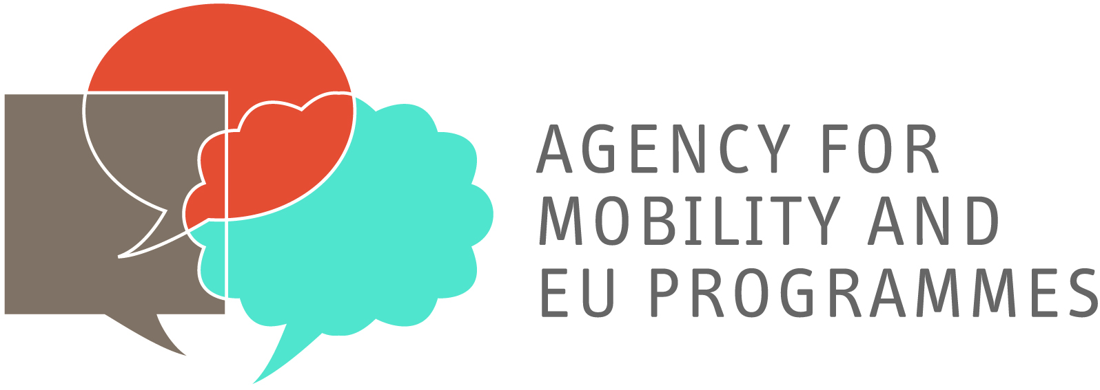

Erasmus Student Placement
EMPLOYER INFORMATION
Name of organization | Aquarium Pula
Address | Verudela b.b.
Postal Code | 52 105
City | Pula
Telephone | +385 52 381 402
Fax | +385 52 381 404
E-mail | infos@aquarium.hr
Website | www.aquarium.hr
Number of employees | 10
Short Description of the Company / HEI / School | Aquarium Pula is the biggest private public aquarium in Croatia, with a 10 year history of constant growth and improvement. An important part of the Aquarium are the educational programmes, where high school students (mostly from Germany) have an opportunity to learn about marine life and oceanography of the Adriatic Sea through different workshops. These workshops include a biological part, where atendees are introduced to different groups of marine organisms typical for the Adriatic, and a chemical – physical part, where they learn basic things about chem. – phys. features of the sea. The programme also includes a guided tour of the aquarium and field work on the coast (tidal zone) with snorkeling.
Other

CONTACT DETAILS
Contact person | Žarko Jaković, dipl.biol.
Department / Function | Curator
Direct telephone number | +385 52 381 402
Direct mobile | +385 91 1381 402
Direct e-mail address | zarko@aquarium.hr

PLACEMENT INFORMATION
Department / Function | Educator
Description of activities | Leading workshops, guided tours and field work on the coast. The applicant will be introduced to our practical work and receive all necesssary assistance in leading the workshops.
Duration | 3 months
Working hours / Weekly hours | Up to 40 hours
City | Pula
Help with finding Accommodation | Yes  No
Financial contribution | Yes 150 €  No
Other

REQIUREMENTS
Oral and written language skills | English (level:intermediate )  German (level: fluent, preffered native )  Other (level: )
Computer skills | basic
Driver's license | Yes  No
Other | Teachers of biology and chemistry preffered, with good communication skills and diving experience

