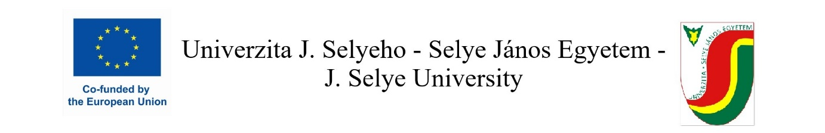
Prolongation Application Form

I, the undersigned..........................................................................................................................
a student enrolled at J. Selye University, Faculty ........................................., participating in a study mobility within the Erasmus+ programme in the winter semester of the academic year ........../........ at ........................................., would like to apply for an extension of the duration of my mobility for the summer semester of the academic year.

In line with the extension of the mobility period, I would also like to request a modification of the mobility grant. I would like to apply for a grant for the whole duration of my mobility.

Date ................................. Student´s signature: ________________________

Approved (Receiving Institution) Approved (Sending Institution)
(institution) J. Selye University

Responsible for Erasmus mobility Responsible for Erasmus mobility
(name) Mgr. Adriana Kinczerová

Date: Date:

Signature: Signature:

Stamp: Stamp:

